**Data initialisation** -> all valid data output as DBHdata

Original data -> 474 rows, 15 columns

Only extract DBH-related data for DBH modelling -> first 9 rows

Assume “No” where there’s blank in “Large”

Remove rows with NA in “DBH.year.0” or NA in “DBH.year.6” -> 11 instances

**Further data preparation for models** -> DBHdatarm, DBHpositiverm

“positive” stands for positive tree growth, i.e. further remove rows where DBH.year.6 <= DBH.year.0 (tree growth <= 0)

“rm” stands for remove outliers (in the scatter plot, points outside the main group)

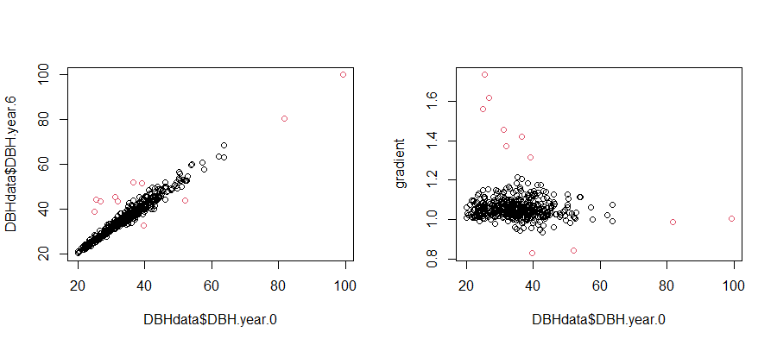

## Tree.Number Plot Treatment Large Alive.at.year.6 DBH.year.0 DBH.year.6 Class.year.0 Class.year.6  
## 20 58 8 T1: Gap Yes Yes 52.00000 43.9000 6 5  
## 95 72 12 T1: Gap Yes Yes 31.85000 43.7000 4 5  
## 96 71 12 T1: Gap Yes Yes 25.50000 44.2000 3 5  
## 141 478 5 T2: Radial No Yes 31.20000 45.4000 4 5  
## 144 172 5 T2: Radial Yes Yes 39.70000 32.9000 4 4  
## 148 174 5 T2: Radial Yes Yes 99.30000 100.0000 NA NA  
## 149 176 5 T2: Radial Yes Yes 81.80000 80.7000 NA NA  
## 156 184 5 T2: Radial Yes Yes 26.80000 43.4000 3 5  
## 157 185 5 T2: Radial Yes Yes 24.90000 38.9000 3 4  
## 198 225 2 Control Yes Yes 36.60564 52.0000 4 6  
## 412 208 7 T2: Radial Yes Yes 39.20000 51.5662 4 6

# **random effect**

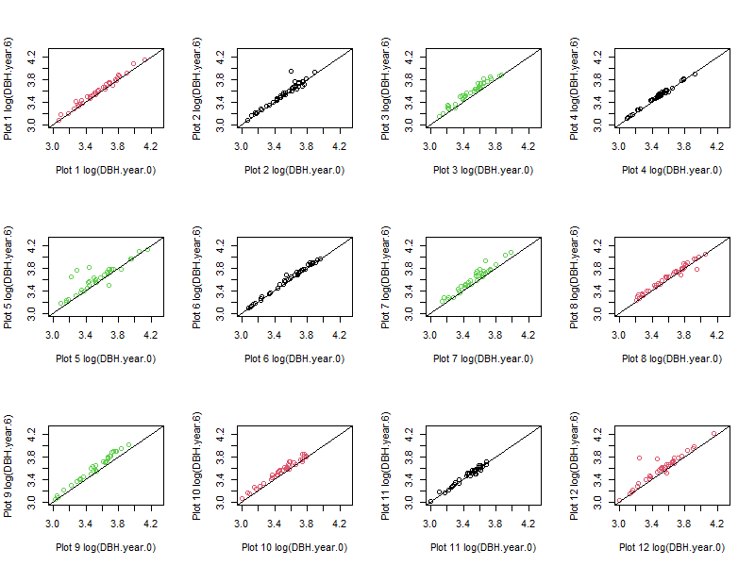

Random effect is not significant. From the 12 scatter plots, it seems that there's no random intercept or random slope.

But it's still necessary to keep the random intercept term as a reference to human errors.

**Models**: random intercept mixed effect model using DBH.year.6 as response variable. Two version: Large VS InGap

**random intercept using InGap for log(DBHdatarm$DBH.year.6)**

Compared to the suggested model: log(DBH.year.6)~log(DBH.year.0)+Treatment+Large+log(DBH.year.0):InGap+Treatment:InGap+(1|Plot),

we’ve removed “Treatment:InGap” and replace “Large” with “InGap” (because “Large” is insignificant when there’s “log(DBH.year.0):InGap”)

**Question:** Whether “Treatment:InGap” is useless? (It’s NA when Control or T1)

mixed2.0 = lmer(log(DBH.year.6)~log(DBH.year.0)+Treatment+InGap+log(DBH.year.0):InGap+(1|Plot), data = DBHdatarm)  
summary(mixed2.0)

## Linear mixed model fit by REML ['lmerMod']  
## Formula:   
## log(DBH.year.6) ~ log(DBH.year.0) + Treatment + InGap + log(DBH.year.0):InGap +   
## (1 | Plot)  
## Data: DBHdatarm  
##   
## REML criterion at convergence: -1778  
##   
## Scaled residuals:   
## Min 1Q Median 3Q Max   
## -3.6211 -0.6010 -0.0148 0.5975 3.2852   
##   
## Random effects:  
## Groups Name Variance Std.Dev.  
## Plot (Intercept) 8.593e-05 0.00927   
## Residual 1.006e-03 0.03172   
## Number of obs: 452, groups: Plot, 12  
##   
## Fixed effects:  
## Estimate Std. Error t value  
## (Intercept) 0.072639 0.027788 2.614  
## log(DBH.year.0) 0.986722 0.007783 126.785  
## TreatmentT1: Gap 0.028683 0.007475 3.837  
## TreatmentT2: Radial 0.039231 0.007962 4.927  
## InGapTRUE 0.452284 0.107566 4.205  
## log(DBH.year.0):InGapTRUE -0.114046 0.029285 -3.894  
##   
## Correlation of Fixed Effects:  
## (Intr) lg(DBH..0) TrT1:G TrT2:R IGTRUE  
## lg(DBH.y.0) -0.982   
## TrtmntT1:Gp -0.095 -0.040   
## TrtmntT2:Rd -0.248 0.125 0.463   
## InGapTRUE -0.237 0.241 -0.010 0.017   
## l(DBH..0):I 0.258 -0.263 0.010 -0.035 -0.998

VarCorr(mixed2.0)

## Groups Name Std.Dev.   
## Plot (Intercept) 0.0092699  
## Residual 0.0317162

y.hat <- fitted(mixed2.0) # Fitted values  
int.hat <- ranef(mixed2.0)[[1]][[1]] # Predicted intercepts  
res.hat <- residuals(mixed2.0) # Estimated residuals  
tss = sum((log(DBHdatarm$DBH.year.6)-mean(log(DBHdatarm$DBH.year.6)))^2) #TSS  
rss = sum((log(DBHdatarm$DBH.year.6)-y.hat)^2) #RSS  
(tss-rss)/tss #R^2 = 0.9801595

## [1] 0.9801595

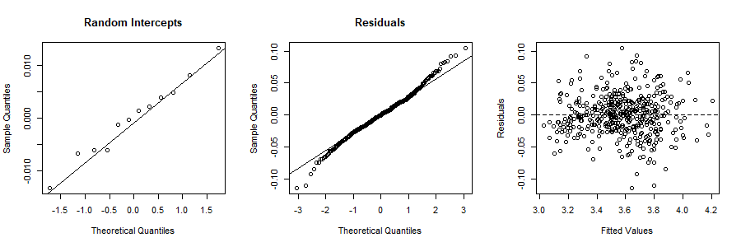

**Reason:** high R^2 value, small residual, simpler model, easy to interpret

**Achievement of this model:** explain priority1

(Thinning will increase tree growth in both treatments relative to the control.

Thinning will have an increased effect on the rate of tree growth in T2 as compared to T1.)

**Problem with this model:**

1. Cannot explain priority2, because “Large” is not included.

(Thinning will increase tree growth in the largest tree class size both treatments relative to the control.

Thinning will have an increased effect on the rate of tree growth in T2 as compared to T1 in the largest tree class size.)

-> use scatter plot of tree.growth VS DBH.year.0 to show trend

1. Cannot explain priority3.1 (larger DBH.year.0 results in larger tree growth). INSTEAD, we can only say: larger DBH.year.0 results in larger DBH.year.6.

(The greater the tree class size the greater the relative increase in the DBH after thinning across both treatments.)

-> use scatter plot of tree.growth VS DBH.year.0 to show trend

1. Coefficients for “InGap” and “log(DBH.year.0):InGap” form constrains for DBH.year.0. Not sure how to interpret the constrains.

Constrains more strict to less strict: InGap>T2notInGap, InGap>T1, InGap>Control; model using DBHpositiverm, model using DBHdatarm

-> guess: few data points over constrains, so model is not accurate for large DBH.year.0

**scatter plot of tree.growth VS DBH.year.0**

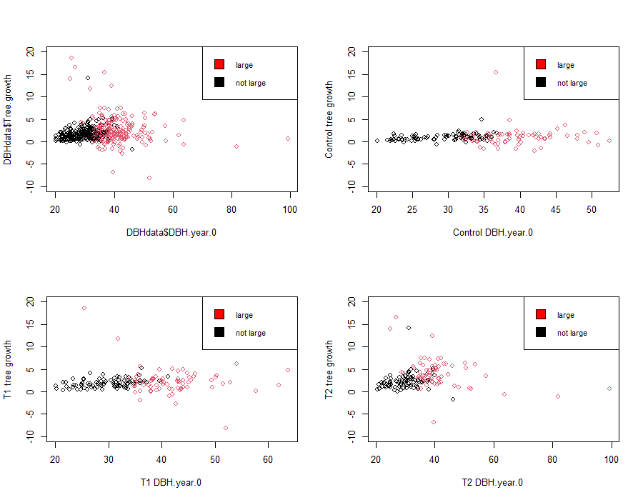

**Visualise constrain according to mixed2.0**

